A Statement of Attainment is issued by a Registered Training Organisation when an individual has completed one or more units.

This is a statement that

Priya Sharma

has attained

Unit Code | Unit Title | Date | Result
CHCICS402B | Facilitate individualised plans | 12/06/2013 | Competent
CHCCS411C | Work effectively in the community sector | 12/06/2013 | RPL-G
CHCAD401D | Advocate for clients | 12/06/2013 | Competent

These competencies from part of CHC40312 Certificate IV in Disability
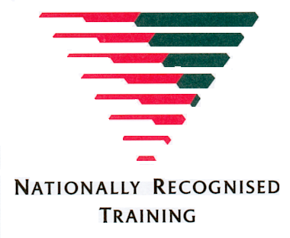

12 June 2013

Statement Number: 21594

Student ID: 245811-65

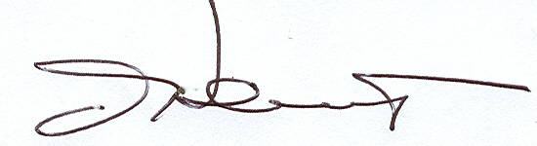
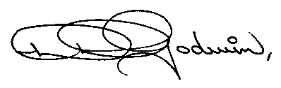

Diane Godwin-Heidt John Heidt
Chief Executive Officer Chief Executive Officer

North Western Support Training Academy Incorporated Pty Ltd
National RTO Provider Number: 3
Obtained under an approved South Australian Traineeship pathway

